CANNABIS SATIVA: AN ECONOMIC SUSTAINABILTY PLANT

INTRODUCTION
Cannabis sativa was first used around 10,000 years ago, during the Stone Age. Cannabis sativa is also known as "marijuana," a term derived from the Portuguese word "mariguango," which means "intoxicant," and it is used in India for cultural and religious purposes (Abel, 1980)

It's a crop that's grown all over the globe. The plant is one of the most reviled, maligned, and despised in the world, and enormous sums of money and effort are being spent to eradicate its production, distribution, marketing, and consumption. Among other controversies, cannabis sativa is incorrectly believed to cause harmful health effects.

However, studies have revealed that this plant, in addition to being one of the five sacred crops, has a wide range of medical, recreational, commercial, and social applications. Marijuana has also been shown to be effective in the treatment and management of chronic diseases such as HIV/AIDS, Cancer, Asthma, Glaucoma, Cachexia, Hypertension, Depression, and others. However, more research is needed to make this amazing plant even more useful to humanity (Ayenigbara, 2012)

Cannabis sativa, also known as marijuana, is a hemp plant that can be found growing wild all over the world. The cannabis plant is best known today as a powerful psychoactive substance, but it was once primarily harvested for its fiber. Rope, clothing, and ship sails were all made from these strong hemp fibers (Maisto, Galizio and Connors, 1999).

The earliest known evidence of cannabis use dates back to the Stone Age, more than 10,000 years ago. Archeologists from a Taiwanese site discovered pots made of fibers thought to be from the cannabis plant during this time. (Abel, 1980)

Cannabis was first used for recreational purposes in Asia, and then as an intoxicant in Europe. Despite what some perceived to be appealing characteristics of Cannabis and hashish, its use did not spread quickly in Europe. In fact, it was not until the 1960s that Cannabis was reintroduced to Europe for its psychoactive properties by tourists from the United States, among others (Carter & Doughty, 1976).
When it was discovered that Cannabis sativa was effective in the control and management of chronic health problems such as HIV/AIDS, Cancer, Cachexia, Glaucoma, Nausea and Vomiting, Asthma, and Hypertension, attention was focused on its medical utility (Cohen and Andrysiak, 1982).

Marijuana is a plant that is well-known and widely grown around the globe. This plant is so well-known and revered that it was even worshipped in India (Ayenigbara, 2012). The plant has a wide range of commercial, agricultural, medical, and social applications. The leaves, stems, and even the back's outer covering are all very useful. While the leaves are smoked for pleasure, the stem has been known to be used to make the strongest rope and pots (Maisto, Galizio & Connors, 1999). Marijuana ropes were also used in the construction of ship sails.

Despite its widespread use, Indian hemp has become one of the most reviled, misunderstood, and despised plants in recent years. Millions of dollars were spent around the world to eradicate the production of this valuable crop due to widespread hatred. Thousands of hectares of Indian hemp farms were demolished, and the crop's producers, marketers, distributors, and users were prosecuted, persecuted, and imprisoned. Even those who are unaware of the crop's utility have been conditioned to despise it.

Increased awareness of marijuana's potential for disease control and management has also contributed to the crop's acceptance, though more research is needed. Following on from the previous paper, this one looked at the controversy surrounding cannabis sativa, its medical utility, and made some recommendations about the need for more research into the general uses of marijuana as well as the specific medical utility of the sacred plant.

PARTS OF THE PLANT:
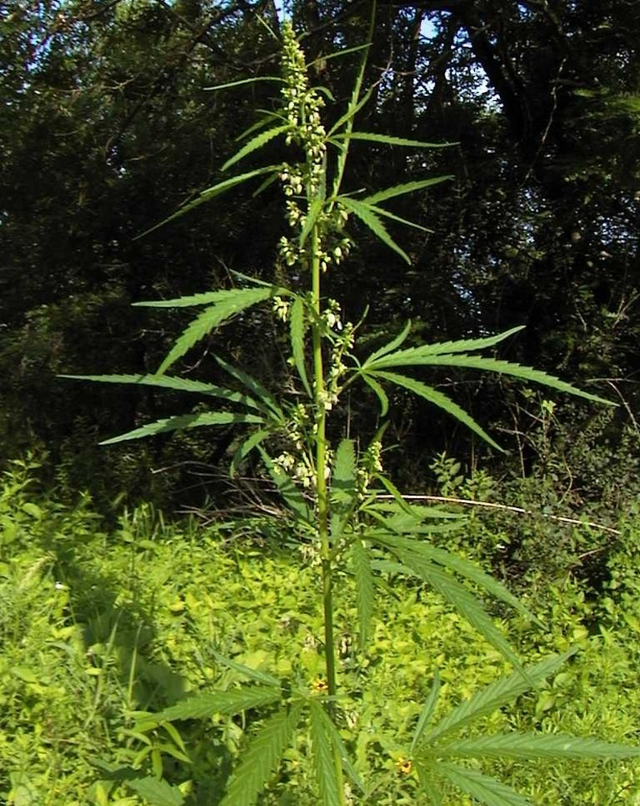
https://lnkd.in/e5Qs5dKZ
- Roots
The plant's root is made up of a single tap root that grows many secondary roots until it becomes a fibrous mass. The vascular system of the cannabis plant includes the roots. Water and minerals are transported from the roots to the rest of the plant via the xylem.
- Main Stem and Branches
The plant's main stem emerges from the root and supports the plant's vertical growth. Water and minerals are transported from the roots to the stem via the stem. The leaf node is the source of secondary growth. On either side of the stem, branches emerge from the leaf node in pairs. Internodes spacing refers to the distance between two consecutive branches. Internode spacing is generally shorter in indica varieties than in sativa varieties.
- Leaves:
Leaves grow in pairs from the main stem and branches of the plant, and act as a solar panel for the photosynthesis process. Leaves also help to distinguish between indica and sativa marijuana species. Indica species have dark, wide leaves, whereas sativa species have light green, lean, and slender leaves.
- Flowers:
These are the most important characteristics that distinguish male and female plant variants. Staminate flowers are produced by male plants, while pistillate flowers are produced by female plants. Early in the flowering stage, male marijuana plants display pollen sacks at internode locations. When these pollen sacks reach the appropriate maturity stage, they open and bloom, producing white or green flowers. Pollen is dispersed throughout the female flowers, fertilizing them.

Pistils are female flowers that are made up of tiny white or orange hairs. During the flowering stage, the Pistils emerge from the internodes. At this stage, female flowers produce small tear-like calyxes with two pistils, which eventually grow and form together into what are known as buds. The recreational and medicinal potential of female flowers is determined by a thick layer of cannabinoid-rich resin that coats them.

Trichhomes are special glands on the plant that produce resin in the shape of a mushroom. This resinous substance is used to seize pollen from male plants in order to carry out the fertilization process.

MARIJUANA CONTROVERSIES
The role of marijuana in enhancing interpersonal skills, the effect of marijuana on aggression and violence, and the role of marijuana use in the motivational syndrome are three hypothesized social and environmental consequences of cannabis use that have received attention. Many marijuana users claim that the drug helps them improve their social skills and make them more competent in social situations. (Ayenigbara, 2012).

Another claim made in the United States, according to newspaper articles from New Orleans in the 1920s, is that marijuana makes people aggressive and violent. The overwhelming conclusion derived from the available data, which includes surveys, laboratory investigations, and field studies, is that cannabis use is not causally related to increases in aggression and violence. When aggression is observed, it is most likely due to the individual drug user's beliefs and characteristics. (Cherek, Roache, Egli, Davis, Spiga and Cowan, 1973).

They claim that when people use cannabis, their levels of aggression decrease. The motivational syndrome is the third and perhaps most contentious social/environmental consequence of cannabis use. Mc Glothlin and West (1968) and Smith (1968) coined the phrase in the late 1960s to describe the clinical observation that “regular marijuana use may contribute to the development of more passive, inward turning, amotivational personality characteristics” (Mc Glothlin & West 1968). Apathy, decreased effectiveness, lost ambition, decreased sense of goals, and difficulty attending and concentrating are among the behaviors proposed as part of the syndrome.

MEDICINAL USES OF CANNABIS SATIVA

Shen Nung, a Chinese Emperor and Pharmacist, used cannabis for its pharmacological effects. It is also used to treat mental illness and pain, and it has sedative properties that can help with anxiety and He also concurred that Marijuana is used for medicinal purposes, according to Ayenigbara (2012), Insel and Roth (2006).

Tetra Hydro cannabinol and synthetic cannabinoids such as Levontrol, Nabilone, and Marinol are active constituents that can be used to treat a variety of disorders. (Sussmann, Stacy, Dent, Simon, & Johnson, 1996; Sussmann, Stacy, Dent, Simon, & Johnson, 1996). Single cannabinoids have anti-emetic, analgesic, and relaxing properties, as well as the ability to increase appetite.

The synthetic Cannabis constituents can be used to treat the following conditions:
- Anorexia and Cachexia
Cachexia and anorexia are eating disorders in which a person loses their appetite and weight, resulting in malnutrition and weakness. This is most common in cancer and HIV patients. Tetra Hydro Cannabinol's synthetic products aid in the enhancement of appetite and the maintenance of body weight. Plase, Gorter, Krasnow, Lane, Shepard, and Wadleigh (Plasse, Gorter, Krasnow, Lane, Shepard, & Wadleigh,1991).
- Spasticity
Spasticity is a condition caused by damage to the spinal cord and brain, as well as muscle contractions that cause stiffness. This includes signs and symptoms such as pain, ataxia, and jerky muscle movements. Cannabis constituents can aid in the recovery of brain and spinal cord damage. (Maisto and colleagues, 1999).
- Nausea and vomiting
Nausea and vomiting are two of the most common symptoms of nausea. Cannabinoids and synthetic Tetra Hydro Cannabinol Nabilone is a drug that is used to treat nausea and vomiting in cancer patients who are undergoing chemotherapies or radiation treatments. However, it has some side effects. (Maisto and colleagues, 1999).
- Movement Disturbances
The therapeutic response and relaxing effects of synthetic Cannabis products in Tourette's syndrome, dystonia, and tardive dyskinesia can be seen.
- Glaucoma
Glaucoma is an eye disease in which the intraocular pressure rises, causing damage to the optic nerves and eventually blindness (Maisto et al, 1999). Cannabis products were once used to lower intraocular pressure, but they had some negative side effects.
- Pain
Cannabis is a psychoactive substance with analgesic properties that can help with headaches, menstrual cramps, arthritis, HIV infection, rheumatism, rabies, and cholera, among other things. (Maisto et al, 1999).
- Psychiatric disorders
Cannabinoids and their derivatives aid in the treatment of mental illnesses such as anxiety, insomnia, epilepsy, bipolar disorder, and depression. It is up to the users to decide whether it is harmful or beneficial. Martin, Cabral, Childers, Deadwyler, Mechoulam, and Reggio (Martin, Cabral, Childers, Deadwyler, Mechoulam, and Reggio, 1993).
- Autoimmune disorders and inflammatory disorder
Cannabis is used to treat ulcers, colitis, arthritis, and allergic conditions in HIV AIDS patients. It is also used to treat ulcers, colitis, arthritis, and allergic conditions. This is used to reduce the need for anti-inflammatory drugs, both steroidal and nonsteroidal (Plasse et al, 1991).

ECONOMICAL AND COMMERCIAL USES OF CANNABIS SATIVA:
For many years, the Cannabis plant was primarily harvested for its fiber. Rope, clothing, and ship sails were all made from these strong hemp fibers (Maisto et al, 1999). Pots made of fibers from the Cannabis plant were also discovered by archeologists at a Taiwanese site.
The seed's drying oil is used in lighting, soap making, paints, and varnish, among other things. Oil is produced in the temperate zone from females that have been left standing after the fibre-producing males have been harvested. The pressed seeds are used to make a varnish (Duke, 1983).
The best fibres are produced by male plants, which are harvested when the plants turn brown and the flowers begin to open. When used to make paper, the stems are harvested in the fall and retted or steamed until the fibers can be extracted. The fiber is cooked with lye for at least 2 hours before being beaten in a ball mill or Hollander beater (Tropical Plants Database, 2021).

PRODUCTS OF CANNABIS
1. Ghanja or marijuana- Marijuana is made from the leaves and flowering tops of cannabis plants and has a high resin content and potency. With a THC content ranging from 1 to 10%, potency is variable.
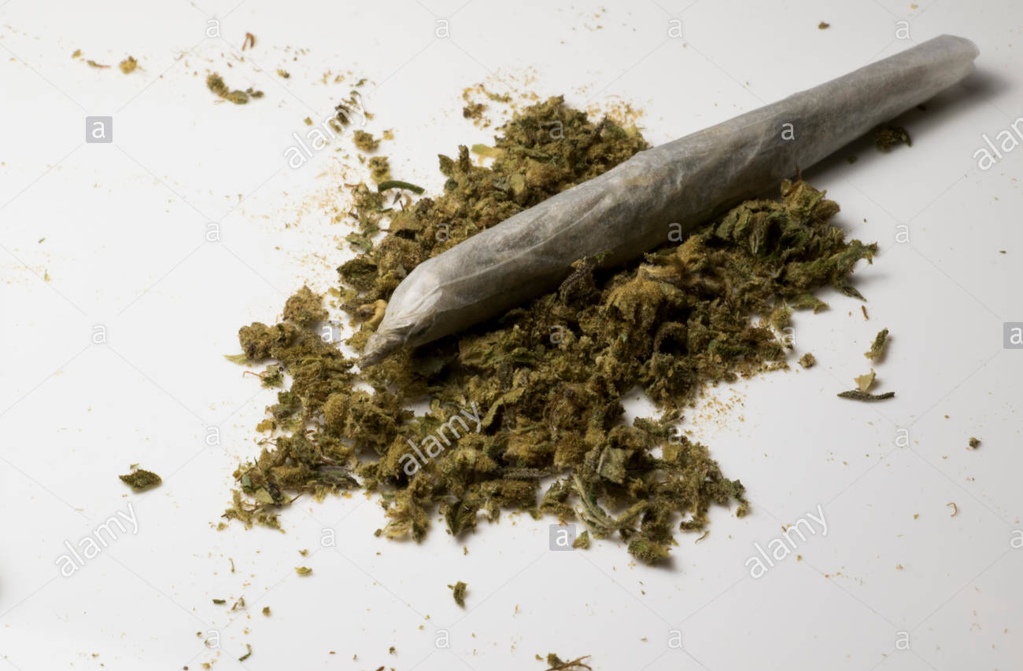
https://lnkd.in/eX9ZSAEP

- Bhang- Bhang is made from the cut tops of uncultivated plants and is the least potent of the three.
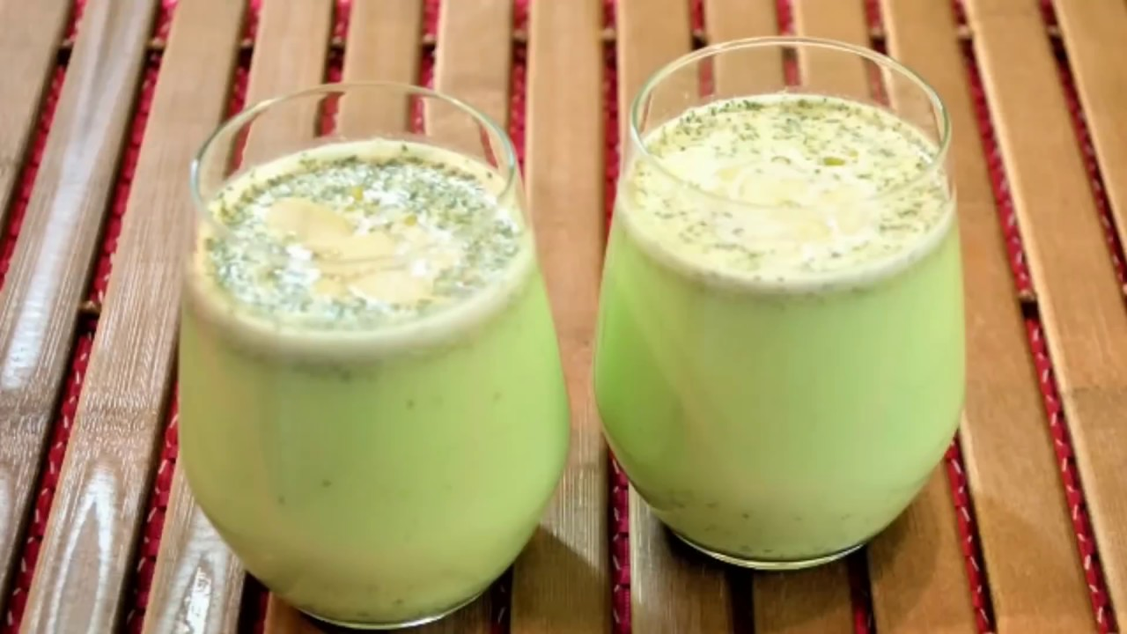
https://kj1bcdn.b-cdn.net/media/28187/bhang.jpg

- Hashish- Cannabis resin (hashish) is a sticky brown cake that can be smoked or eaten and is made from cannabis.
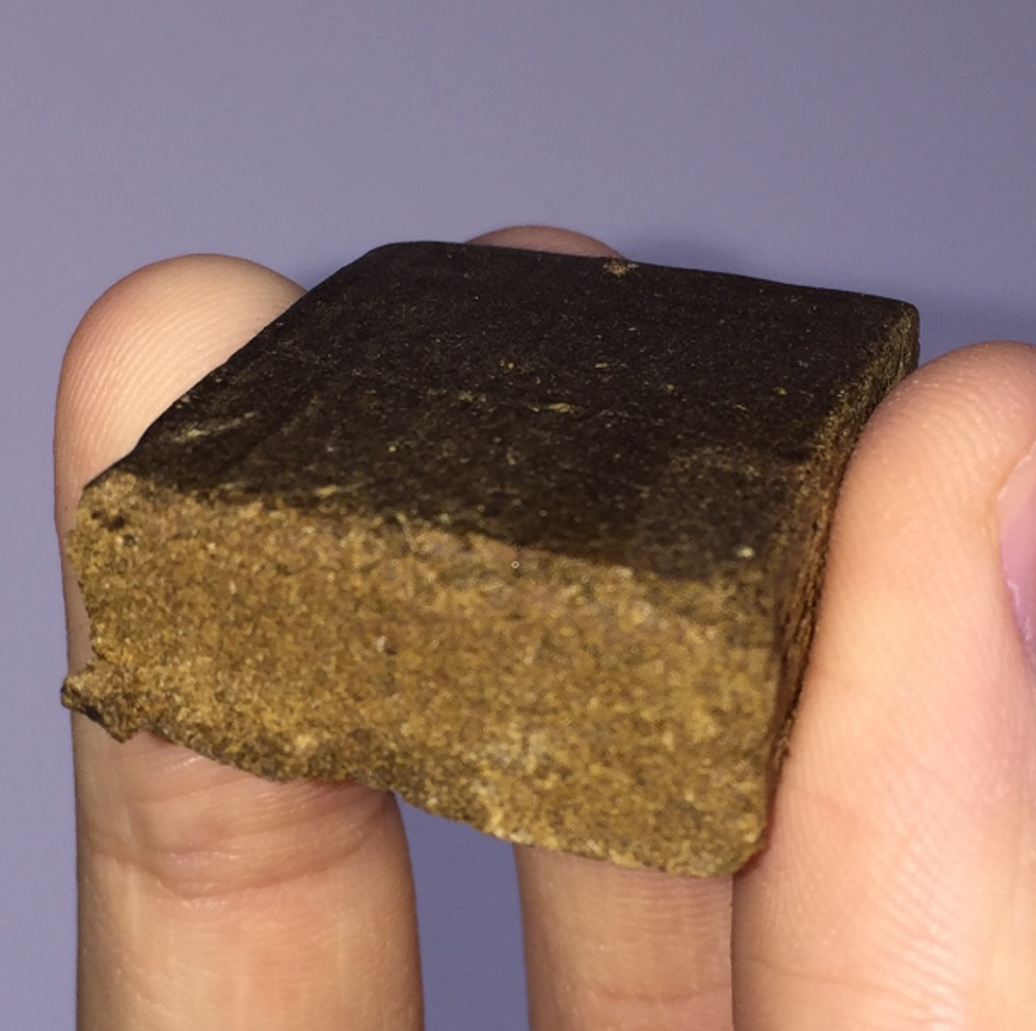
https://lnkd.in/ermv_V6U

- Hashish oil- Hashish oil is the name given to liquid cannabis. It is more potent because it is extracted from cannabis resin. Before smoking, the tobacco is dipped in this hashish oil. It's a Class A drug that contains up to 60% THC.
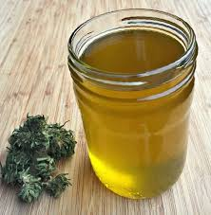
https://lnkd.in/eA_rGD7H
Cannabis plants and products contain a large number of different chemicals. The more than 60 cannabinoids, for example, are unique among the 483 Cannabis compounds identified, whereas terpenes, with about 140 members forming the most abundant class, are found throughout the plant kingdom. There are over 300 compounds in cannabis.

In the cannabis plant, there are five important cannabinoids namely: Tetrahydrocannabinol (THC), Cannabidiol (CBD), Cannabinol (CBN Cannabinol (CBN), β-caryophyllene and Cannabigerol.

ABUSE OF CANNABIS SATIVA
Despite the numerous benefits of cannabis sativa, the therapeutic and medicinal uses of cannabis sativa are also abused, particularly by teenagers. This substance is widely used for recreational purposes. When cannabis smokers smoke in front of others, they feel more satisfied and their livelihood improves. Cannabis smoke in the form of joints is mostly consumed in the evening and when the weather is cold. It is used at parties in India, where the youth dance around a logwood fire. This drug is used for fun, pleasure, and to forget about all of life's worries and realities. As a result, Cannabis is widely used in India and has received religious and cultural approval (Chanchal Gokhale, Rajkumar Bhardwaj, 2018).

CONCLUSION
Marijuana (Cannabis sativa) may be a wonderful and sacred plant that's grown everywhere the planet. It is a plant beset by unfounded suspicions and controversies that have severely limited its utility to humanity. Aside from getting used for recreational purposes, marijuana are often wont to treat a spread of chronic diseases that have eluded medical treatment, including HIV/AIDS, cancer, and asthma.

RECOMMENDATIONS
Marijuana is a commercially and economically valuable plant. In terms of economics, I proposed the following:
- Cannabis Sativa should be legalized, with extensive health education and other strategies in place to prevent abuse, so that it can provide jobs for the commodity's producers, distributors, and traders.
- More research on Cannabis Sativa should be conducted so that mankind can benefit from the crop's medical, commercial, agricultural, social, recreational, and economic potential.

REFRENCES

Abel, E.L. (1980). Marijuana: The First Twelve Thousand Years. New York: Plenum Press
Ayenigbara G.O (2012, May-June). Medical Utility of Cannabis Sativa. IOSR Journal of Pharmacy, 2, 460-463. Retrieved from iosrphr.org
Carter, W.E. & Doughty, P.L (1976): Social and Cultural Aspects of Cannabis use in Costa Rica. Annals of the New York Academy of Science, 282, 2-16 ).
Chanchal Gokhale, Rajkumar Bhardwaj. (2018, August). Brief study of Cannabis sativa: A Review. International Journal of Information and Computing Science, 5, 128.
Cherek, D.R., Roache, J.D., Egil, M., Dailis, C., Spiga, R., & Cowail, K. (1973): Acute effects of Marijuana smoking on aggressive, escape, and point-maintained responding of male drug users. Psychopharmacology, 111, 163-168
Cohen, S., & Andrysaiak, T. (1982): The Therapeutic Potential Marijuana‟s components. Rockville, M.D: American Council on Marijuana and other Psychoactive Drugs.
Duke J. (1983). Published only on the Internet, excellent information on a wide range of both temperate and tropical plants. Handbook of Energy Crops.
https://kj1bcdn.b-cdn.net/media/28187/bhang.jpg
https://lnkd.in/e5Qs5dKZ
https://lnkd.in/eA_rGD7H
https://lnkd.in/ermv_V6U
https://lnkd.in/eX9ZSAEP
Insel, P.M; and Roth, W.T. (2006). Core Concepts in Health. 10th ed. Mc Graw Hill, Nicoll and Alger (2004) Nicoll, R.A; and Alger, B.E. (2004). The Brains Own Marijuana. Scientific American. 291, 68 – 75.
Maiston, S.A., Galizio, M.G., & Connors G.J. (1999): Drug Use and Abuse (3rd Eds). New York: Harcourt Brace College Publishers.
Martin, B.R; Cabral, G; Childers, S.R; Deadwyler, S; Mechoulam, R; and Reggio, P. (1993). International Cannabis Research Society Meeting Summary. Keystone, C.O. (June 19-20, 1992). Drug and Alcohol Dependence, 31, 219-227.
McGlothlin, W.H., West, L.T. ( 1968): The Marijuana Proble: An Overview. American Journal of Psychiatry, 5, 0 – 8.
Moisto, S.A; Galizio, M; and Connors, G.J. (1999). Drug Use and Abuse. (3rd ed.), Harcourt Brace College Publishers, New York
Plasse, T.F; Gorter, R.W; Krasnow, S.H; Lane, M; Shepard, K.V; and Wadleigh, R.G. (1991). Recent Clinical Experience with Dronabinol. Pharmacology, Biochemistry, and Behavior, 40, 695 – 700
Smith, D.E (1968): Acute and Chronic Toxicity of Marijuana. Journal of Psychoactive Drugs, 2,37 – 47.
Sussman, S; Stacy, A.N; Dent, C.W; Simon, T.R; and Johnson, C.A. (1996). Marijuana Use: Current Issues and New Research Directions. Journal of Drug Issues, 26, 695 – 733.
Tropical Plants Database, Ken Fern. Tropical.theferns.info. 2021-09-18. <tropical.theferns.info/viewtropical.php?id=Cannabis+sativa>).

