IoT BASED SMART HOME AUTOMATION IN RURAL AREA



1. ABSTRACT: - The widespread use and advancement of technology is what separates urban from rural India. Urban Indians have acclimated to technology over the past two decades. Population of India's cities has embraced and supported contemporary technologies and have started using it in their daily lives. After a comprehensive survey of the rural India, it became clear that people there wish to accept and adapt to the newest technology and utilize it in their homes and daily life. In order to bring about change in the day-to-day lives of India's rural people, we have explored a growing technology, namely home automation, as well as its methodologies and the role of the Internet of Things (IoT). Home automation systems is a very rapidly growing interest among the people of this generation, and it has got considerable amount of attention after the introduction of communication technologies. In field of Smart homes, IoT has played a very significant role to help it grow. IoT on its most basic terms is connecting things like software and sensors to internet, enabling them to

collect and exchange data without human intervention. IoT deals with AI sensors, cloud messaging, networking, etc. and aims on delivering complete information at the right time. IoT based systems have greater transparency, control, performance as well as efficiency. The two primary concerns with home automation are, security and energy utilization.

Keywords: Energy Conservation, ZigBee, Phone, Bluetooth, GSM, Microcontroller, IOT, Home Automation.

2. INTRODUCTION
Technology and human mentality are both evolving daily throughout the world. People in today’s modern generation prefer to solely rely on technology for their work as well as daily lives. Human-Machine interaction has become very popular, plausible and realistic.
Smart home technology is any collection of devices and systems that are linked to a network and have remote control and independent operation capabilities. Using your smartphone or a mobile touch - sensitive device, you may control the temperature, lights, music players, TVs, door locks, gadgets, and more that are all connected to one system in your house.

Internet on the other has helped this human interaction to move one step ahead. In the past, the internet was predominantly used for communication, but today it is utilized for a wide range of purposes. This thing controlling feature of Internet has developed a new branch of Internet of Things (IoT).
The Internet of Things (IoT) can be summed up as the linking of common objects to the internet, that have sensors, electronics and software incorporated in them. It helps in gathering and communicating data without the need for human involvement.

Smart home automation is connecting and controlling devices via a central smart home hub. Devices like smartphones, TVs, washing machines, sensors, refrigerators, lights have been a part of our day-to-day life, which can be interconnected in a network via sensors, actuators, and controllers to form a system which helps in not only increasing the comfort of people but also their safety, and increase their efficiency in everyday work. The market is filled with a huge number of smart home appliances. An example of such smart home appliances is a smart bulb that can be operated directly through an app.
Almost all home appliances used by people can be categorized as IoT devices and can be used in home automation to make the life of a common person a lot easier.

Smart home automation has made high-tech utility and luxury accessible to everyone in ways that weren't before possible. As technology develops, home automation will have a greater potential to enhance quality of life.
3. LITERATURE SURVEY
R. Teymourzadeh, Salah Addin Ahmed, Kok Wai Chan and Mok Vee Hoong, "Smart GSM based Home Automation System," 2017. This paper aims on the usage of Global System for Mobile Communication (GSM) modem to control all the devices that are a part of any automated home. In support of this statement the paper proposes on the various features of GSM protocol. Also, it suggests the use of PIC16F887 microcontroller with GSM enhances the technology. Somani, P. Solunke, S. Oke, P. Medhi and P. P. Laturkar, "IoT Based Smart Security and Home Automation," 2018 this research is all about how appliances are installed with sensors and actuators allow the data transfer over a network. Also, this suggests how to installation of these smart IoT based devices in our houses can enhance the automation process in our house. This paper also suggests the Security features of this technology. L. Li, H. Xiaoguang, C. Ke and H. Ketai, "The applications of WiFi-based Wireless Sensor Network in Internet of Things and Smart Grid," 2016 suggests that Wi-Fi-based wireless sensor networks offer unique features that other Internet of Things (IoT)-based devices do not. A few of these features include high bandwidth, a high transmission rate, non-line-transmission, and a feature that is very different from other IoT devices: video sharing. This WSN is a very economical approach. The study also makes recommendations on how IoT technology might advance as a result of this technology. The use of WSN in IoT in smart grid, smart agriculture, and intelligent environmental protection serves as the paper's ultimate conclusion. R. Piyare and M. Tazil, "Bluetooth based home automation system using cell phone," 2016 suggests how smart home automation can be achieved by Arduino BT board. This suggested system in this is cost effective and feasible. It also provides password protection so that only authorized person can access the appliances. M. J. Iqbal et al., "Smart Home Automation Using Intelligent Electricity Dispatch,", 2021, advocates using this technology in an energy-efficient way so the financial and ecological concerns are maintained as a solution to one of the primary issues with smart home automation. This paper offers a solution by recommending manual, app-based, or web-based device switching based on the requirements of the user.

- IoT IN SMART HOMES
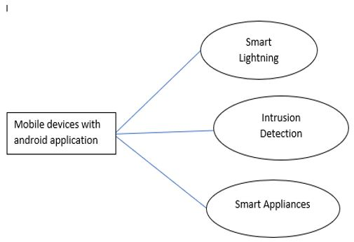
Fig1. A Diagram of Smart Home Automation

Home automation is making a smart home. In the IoT home automation system, you can handle your appliances like lamp, ac, television, etc. A household automation system is a very useful technology that can monitor as well as control aspects of the home. In such this particular technology devices are often connected to a gateway or central hub over a network.

The control system uses not only wall- mounted terminals, but also mobile devices like tablet or desktop computer, as well as applications that can be accessed via smartphones and other devices, or even virtual internet connection that can be accessed off-site via the internet.

  - Smart Lighting
Smart house lighting reduces energy consumption by adapting to the surrounding conditions and turning on, off, or dimming the light as needed.

  - Smart Appliances
Smart machines with device managers exist and they provide status information to users remotely.

4.3 Intrusion Detection
Security cameras and other sensors are used by home access systems to detect intrusions and send out notifications and raise alerts as required.

- DIFFERENT METHODS OF HOME AUTOMATION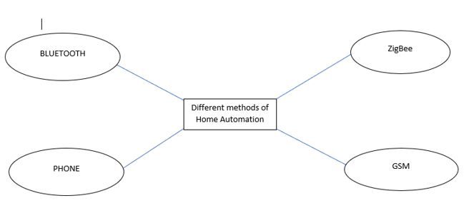
Fig2. Flow chart for different method of Smart Home Automation

  - Bluetooth
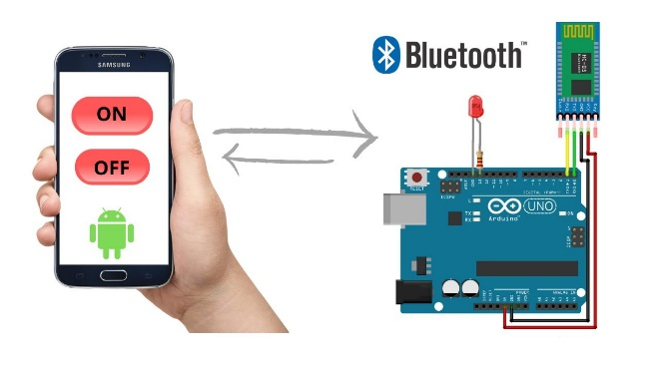
Fig 3: App based controlling using Arduino BT ^{[15]}
A digital device can communicate with another digital device within close proximity using the Bluetooth wireless communication technology. It is a cost-effective and dependable technique. A user interface for a mobile phone running an interactive Application is provided via an Arduino Bluetooth board. The I/O ports on the Bluetooth board are used to communicate with and control the devices. It also aids in preventing unauthorized access from abusing the system. Password protection on Bluetooth makes it safer to use. The range of Bluetooth is 10 to 100 meters. The Bluetooth standard protocols state that it operates at a speed of 3 Mbps while using 2.4 GHz bandwidth. The app is transferable and is a fast as well as an efficient system that can send and receive timely diagnostic reports by a feedback system. Bluetooth technology can only be accessed within its range.

Bluetooth system has both merits and demerits. The main disadvantage being its short range (approx. 10 meters) making it unable to fit into the newer technologies whereas its main advantage is it fits very conveniently in an existing system. It is an inexpensive method to achieve basic home automation.

  - Phone based
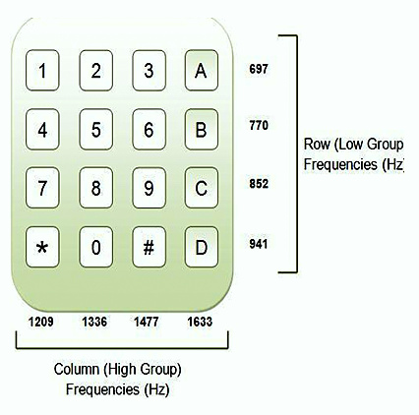
Fig 4: DTMF phone frequencies ^{[16]}
We can create a fully functional phone system using the DTMF (dual tone multi frequency) principle [5]. in this, the entire system is divided into 3 functional components. The first unit has a DTMF that picks up signals and also consist of a ring detector that is connected to it. The unit that will manage the system's input and output follows this. Finally, it contains a PC/hardware device that will carry out the user's requested commands.

One of the shortcomings of this system is how many devices it can be connect to. Because standard phones all over the word have only 12 keys so the user can only connect 12 devices. It is not only affordable as well as the working speed of the system is fast.

  - ZigBee
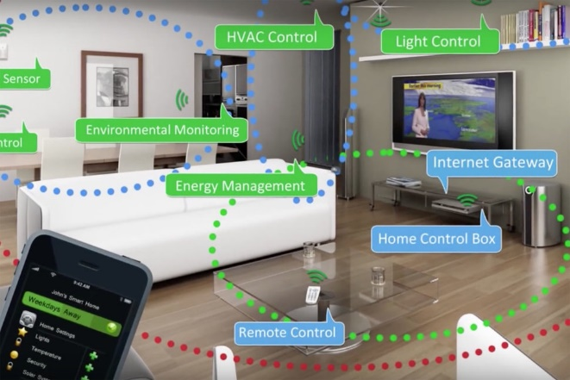
Fig 5: ZigBee based home automation system ^{[17]}

ZigBee wireless technology is a universal standard that not only meets the particular requirements of wireless machine-to-machine networks and the Internet of Things (IoT), but also does it in a way that is both economical and energy friendly [6]. It operates on IEEE 802.15. This technology of wireless communication proves to be very useful in smart home. For this process, it uses PIC microcontroller and voice recognition. Voice commands are taken from input devices like microphones.

ZigBee is very simple to implement as well as to understand. The voice instructions are used as input, and a recorded and processed voice is used as a comparison. Following this, a PIC microcontroller is used to carry out the task. One PIC controller communicates the orders through ZigBee to the receiver, while a second PIC microcontroller carries out all the processing. Relays are used by this microcontroller to operate the relevant appliances.
The range of ZigBee is just approximately 291 meters, which is relatively short and hinders the transmission of commands. The speech recognition module becomes difficult to utilize as a result. But in contrast to the limited coverage area, ZigBee is the most cost-effective and power efficient smart home automation tool.

  - GSM
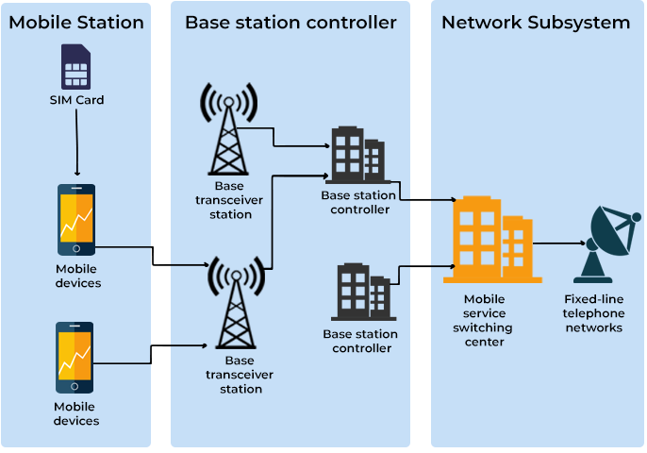
Fig 6: Working of a GSM model ^{[18]}

The system proposed in the following method has three key elements for managing the home appliances, namely, the internet, GSM, network and voice control [12]. Real-time control and communication with household appliances is one of the primary aspects of home automation. Through a pc, the user sends instructions to the server. The server transmits these instructions to the appropriate units for implementation after processing every command given by the user. Establishing a reliable internet connection is made easier by GSM. To establish a connection or communicate with a GSM modem, the server uses attention (abbreviated as AT) commands.

J2ME is used to build the mobile interface [13]. The database, the voice recognition software, the primary control program, and the web server are the four major functional components of its server. The confirmation messages are transmitted via the device's built-in SMS service [14]. For voice recognition, a dynamic time wrapping method is employed. Speech input using a wireless unit or gadget situated in the home is more effective than voice activation, which turns out to be an impractical method. Each application node is made up of four parts: a microcontroller, transmitters, I/O unit, and receivers. The server's primary control program aids in gathering different data about the device utilizing its transceivers.

GSM provides several benefits, including wide coverage, high availability, security, and accessibility to the general public. There is a chance that SMS delivery will be delayed [14]. Its drawbacks include the need to deploy repeaters to expand coverage and the possibility of electrical interference.

  - MIXED TYPE
The process for deploying home automation through the fusion of all previously covered technologies is covered in this section. The user will manage the appliances using an intuitive and easy to use android application. The user can effortlessly command a desired action to be performed just by using their voice. These orders are subsequently delivered by SMS to another device, where they can conveniently be forwarded over Bluetooth to a PIC controller. These instructions are sent to a ZigBee transceiver via a PIC controller. In order to complete the necessary operation, the ZigBee ultimately employs the same method that was discussed in section 5.3 of this research paper.

Since it makes use of several controllers and numerous distinct technologies, this approach of merging and utilizing all of the technologies is not commonly employed. Additionally, the ideal option for home automation isn't to rely solely on SMS for quick and reliable data delivery.

- Discussion
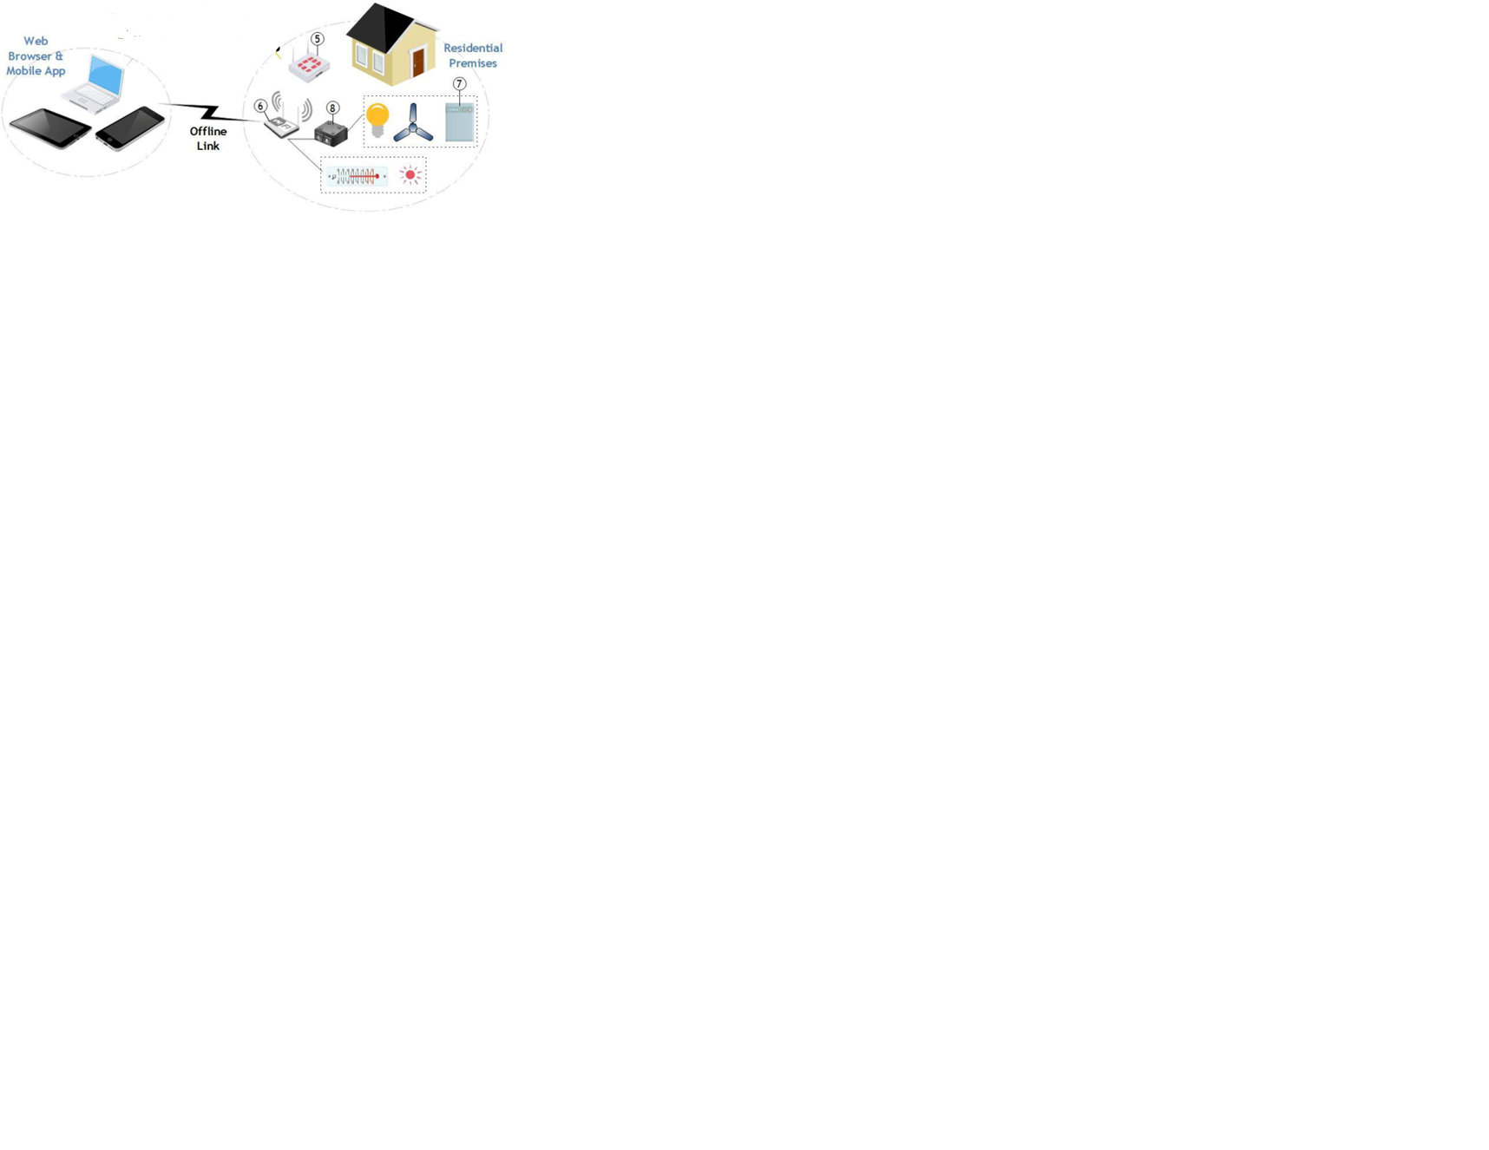
Fig 3: App based controlling of Home appliance. ^{[19]}

We must thoroughly compare each one in order to determine the best approach to take when integrating home automation in any region. The key elements that all approaches have in common are their reliance on the same core communication technology and their use of control circuitry as an interface with electrical equipment. All of these approaches receive their advantages and disadvantages from their underlying technology.

User interface is the next most crucial component of home automation. It provides required amount of control of user over the system and builds the user system understanding. It also affects how broadly the system may be used [14].

A crucial component that all users demand from home automation systems is security, which makes sure that only authorized users have access to their appliances. Some of the most prevalent approaches used in home automation systems are GSM, Bluetooth, WSN, and combinations of these technologies.

You can operate appliances using home automation from anywhere on the globe. However, depending upon the locality cost may differ. This system's unreliability—where there is no assurance that the message will be delivered—is a serious drawback. This drawback of home automation makes it challenging to connect with and regulate appliances in real-time.

GSM may communicate with users through software and network connectivity. As long as the user is near to the gadget Bluetooth can provide user with a strong connection using a smartphone or computer. It is capable of operating as a system design. Communication happens quickly and frequently. It indicates that the user can get notifications of events as necessary. It cannot offer its services to the individual if they are outside their home. The range provided by Bluetooth is its main demerit which is only about 10 meters.

To transmit instructions with handset functions one can, use those double frequency values. Phone based automation system is dependent on the transfer of commands via phone call from any remote area. The disadvantage here is DTMF tones which are in limited amount.

ZigBee is a Bluetooth-compatible alternative technology. It has the same benefits and drawbacks as the GPS. It is new technology which uses wireless system for messaging. These could be radio frequency or electromagnetic rays. It is also capable of powering a system's behavior. The only drawback here is the spectrum's variation and accessibility. Radio waves have a much greater range and are ideal for remote access. However, the existence of the spectral region must be considered. Certain spectrum products are in high demand, while unlicensed bands are used in many other implementations. There is a chance of invasion. It jeopardizes the program's security. Many systems use a fusion of the research methods to reimburse for the shortcomings of each. Such a hybrid execution can result in sound systems. The only factor that may impact such systems are the cost of the frameworks and the prospect of duplication of effort. Some other component in which structures differ greatly is the user interface. Early systems had marginal or no user interface and relied on keys for the user to enter commands to the controllers. On the other hand, modern systems have intuitive user interfaces that have been meticulously designed. New phones seem to be used mostly these days [14]. Smartphones are a useful method for managing home automation systems overall. Another option is to use web applications, which can run on browsers. It is also a popular option, but it is not as convenient. Table 1 provides a comprehensive correlation of all system an application.

Table 1 Comparison Report of all System

System Type | Mode Of  Communication | Range of Access | Number of Devices | Cost of  Installation | Speed of  delivery
GSM | SMS messages | Unlimited access | Unlimited | High cost because of SMS charges | Slow
Bluetooth | Bluetooth and AT commands | Standard 10  meters | Unlimited | Protocol is free and installation is low cost. | Fast
ZigBee | Zigbee and AT command | Expected range is 291 meters. | Unlimited | Protocol is free to use but  installation is  costly | Maximum speed 250kbps
Phone Based | Telephone lines | Anywhere with phone | 12 | Quick | Quick

- IMPLEMENTATION ARDUINO BLUETOOTH BASED HOME AUTOMATION

Introduction

In this section we are going to show the basic implementation of Bluetooth based home automation using Arduino on a smaller scale.

Apparatus Required

The apparatus or components required for building a Bluetooth Based Home Automation Using Arduino are as follows: ARDUINO NANO REV3, HC-05 Bluetooth module, 5-volt 1 channel Arduino relay module, a few male-to-male jumper wires, and a breadboard.
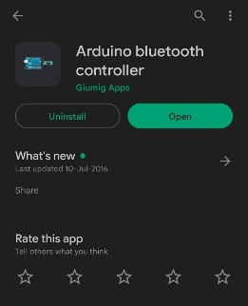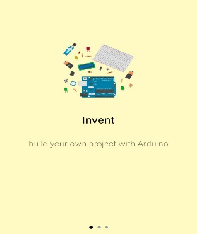
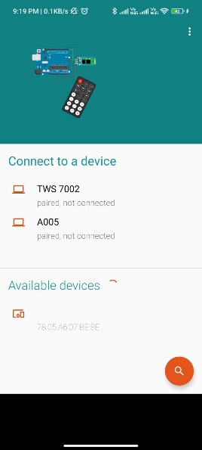

Fig 4: illustrations of the app
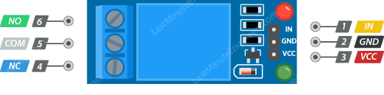
Fig 5: 5-volt 1 channel Arduino relay module
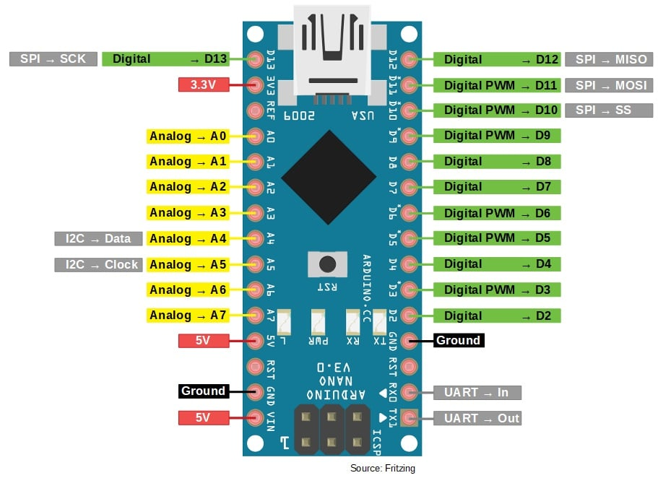Fig 6: ARDUINO NANO
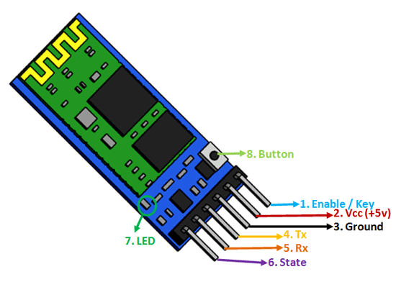
Fig 7: HC-05 Bluetooth module
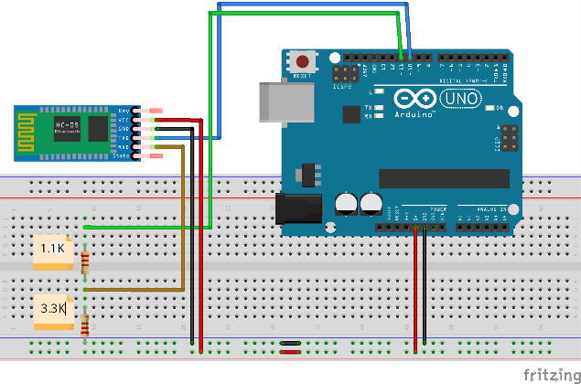
Fig 8: Bluetooth HC-05 with Arduino
  - Implementation work
- On the breadboard, place the Arduino NANO.
- Using the male header pins, attach the Arduino relay module to the breadboard.
- Finally, attach the HC-05 Bluetooth module to the breadboard.
- Now, using the male-to-male jumper wires connect the:
- 5-volt pin of Bluetooth module to VCC pin of Arduino relay module;
- the ground pin of Bluetooth module to the ground pin of relay module;
- VCC pin of Arduino relay module to Arduino NANO 5- Volt pin;
- ground pins of relay module and Arduino NANO;
- IN pin of relay module to the second digital pin of Arduino NANO;
- TX pin of Bluetooth module to RX pin of Arduino NANO;
- RX pin of Bluetooth module to TX pin of Arduino NANO.
- To supply the external 5-volt, we will connect the IN pin and ground pin.
- Before connecting the breadboard with PC using a USB cable, make sure to disconnect the TX and RX pin from Arduino NANO side.
- Using the Arduino IDE, select the appropriate settings and upload the required code. After uploading the entire code, disconnect the breadboard and PC as well as remove the USB cable from the breadboard.
- Now reconnect the TX and RX pin of Arduino NANO and connect the external 5 volts.
By Using an app named Arduino Bluetooth controller (which is already available on Play store), the user can connect there Bluetooth chip-controlled household appliances to your phone and later control them.
  - CODE for Arduino nano chip
#include<SoftwareSerial.h>
SoftwareSerial bluetooth(0, 1);
char BT_input;
const int R1 = 2;
const int R2 = 3;
const int R3 = 4;
const int R4 = 5;
void setup ()
{
bluetooth.begin(9600);
pinMode(R1, OUTPUT);
pinMode(R2, OUTPUT);
pinMode(R3, OUTPUT);
pinMode(R4, OUTPUT);
}
Void loop()
{
if (bluetooth.available())
{
BT_input= bluetooth.read();
if (BT_input == ‘O’)
digitalWrite(R1, LOW)
else if (BT_input == ‘F’)
digitalWrite(R1, HIGH);
else if (BT_input == ‘S’)
digitalWrite(R2, LOW);
else if (BT_input == ‘E’)
digitalWrite(R2, HIGH);
else if (BT_input == ‘T’)
digitalWrite(R3, LOW);
else if (BT_input == ‘K’)
digitalWrite(R3, HIGH);
else if (BT_input == ‘L’)
digitalWrite(R4, LOW);
else if (BT_input == ‘D’)
digitalWrite(R4, HIGH);
}
}
- ADVANTAGES OF HOME AUTOMATION
The ease and comfort of living distinguish the lifestyles of those in urban India from those in rural India. Although technology has largely spread throughout India over the last ten years, there is still a long way to go. We can anticipate the expansion of technology in rural areas now that everyone in India, both urban and rural, possesses a smartphone and has access to the internet. The introduction of home automation is one of the many methods to enhance living comfort and lead a lavish lifestyle. We can implement many technical breakthroughs that the contemporary world has already witnessed in such regions using the technology that has already been established in rural areas.

MANAGEMENT OF HOME DEVICES
Home automation allows an individual to single handedly manage all their appliances and gadgets from an easy-to-use single interface. Smart homes provide enormous comfort. Home automation is a big leap forward in technology as well as home management systems. In this technology, all the user has to learn is how to operate a single application through their mobile device. Once the user becomes familiar with the application, they are ready to faucet into plethora of functions and devices all across your home. This comfortable and convenient interface, i.e., the application helps lowering the learning curve for them.

FELXIBLE ADDITION OF NEW TECHNOLOGY
Smart homes provide greater flexibility in adding new devices and appliances in the pre-existing network of devices. Using home automation pushes an individual to acquire and accommodate gadgets with newer technology embedded in them. This makes their home not only pleasing to outsiders but also helps them in managing and securing their homes. Individuals can accommodate these newcomers without facing any difficulty. This helps the owner to keep in touch with the latest home related technologies

WIRELESS HOME SECURITY
Home automation system offer tremendous security advantages. They give you genuine peace of mind by allowing you to monitor your house from a distance. Some systems provide remote arming and disarming of your house's security system, and to communicate with your surveillance system. You may be notified by phone, text, or email whenever there are any strange movements inside your home by some full-home automation systems. By managing and lowering your energy usage, you can easily save on your finances monthly. Perhaps most crucially, full home automation enables you to adapt your house to your family's needs and way of life.

REMOTE CONTROLLED HOME
Remote access to your home can prove to be of great advantage in every possible aspect. For instance, you can easily manage your home’s temperature which you desire to have when you are about to reach home or set your oven to preheat while you do rest of the preparation of your meal. Additionally, you can manage your home appliances while you are away or check on your entrance door and windows whenever you wish to do so.

INCREASES ENERGY EFFICIENCY
An individual can easily make their home and its appliances more energy efficient by using home automation in a well-mannered way. For instance, a temperature controller can recommend energy efficient settings to you, by studying your daily patterns and requirements which you manually set or change according to your surroundings, you can set your lights to automatically dim or your drapes to automatically set themselves according to the time of day. You can also make sure that all the appliances were turned off after you left from home so as to save not only on your monthly budgets but also save you and your home from hazardous and dangerous unwanted situations or accidents.

HOME MANAGEMENT INSIGHTS
Additionally, your capacity to gain knowledge and have detailed insights about how your house functions. You can track your energy use patterns over time, by keeping an eye on how frequently you watch Television, how often you prepare your meals in your oven, what kinds of items you store in your refrigerator. With the help of these revelations, you might be able to evaluate your routines and behaviors and make necessary changes to lead the lifestyle you wish.

CONVINIENCE
Being home when the kids arrive at the door or the repairman arrives can be challenging due to life and traffic. The simplicity of being able to access your home equipment remotely can also be a significant time saver because you cannot be at two places at once. Without getting out of bed, switch off every light in your house. Turn on/off your wireless house security alarm system using your cell phone or a portal device, or use voice commands to operate appliances throughout the house.

SAVES MONEY AND TIME
We don't even have time to think about our house because we live in such a fast-paced environment. By using home automation, we could save the time returning home to check on things like whether the kids locked the door after school or turned on the lights when we got home.
The main benefit of home automation is this. Homeowners will save money if they can manage the lights, either by dimming it or turning it on and off at particular times. Keeping your home at a comfortable temperature can help you save money when your window treatments and thermostat are properly automated. In addition, you can save gas by staying put if you forgot to lock the door or switch off the appliances at home.

- RESTRICTIONS EXPECTED DURING IMPLEMENTATION

To implement this model in a rural area we will have to resolve many issues related to this system. Few of the restrictions that we might face are listed below:

Electricity supply: - The constant availability of energy is one of the top problems in the majority of Indian villages. Lack of electricity may cause the gadget battery to fail, which would cause the system to shut down.

Network issues: - The availability of a network for techniques like Wi-Fi-based WNS to function is the second problem that emerges when it comes to village areas. However, we have already suggested using Bluetooth or DMTF solutions to address this issue.

Trust building: - Since the villagers have long operated in a traditional manner, introducing modern technology into their daily lives will require us to persuade them that their lives will improve as a result of these gadgets.

Education of Tech: - As was previously discussed, it is important to educate the villagers about these technologies, including how they operate and what the supporting mechanisms are.

These were some of the most important problems we anticipate encountering throughout the project's initial execution phase. We can encounter some more and brand-new problems in the remaining phase. But while putting this plan into action, one thing we must remember is that our major objective is to give the villagers a comfort living while using few resources. So that the lifestyle differences between rural and urban areas may become comparable.

- Conclusion
In today’s modern world every human being wishes to lead a luxurious and comfortable lifestyle. These days none of the people residing in urban cities wants to go back to the rural areas because the rural areas lack many services that are easily available in cities. So, in this research paper we have introduced different methods with which we can provide a smart home lifestyle to people living in rural areas. These methods include technologies which we have discussed in our paper some of which are, ZigBee, GSM, Bluetooth, and a combined system using all these technologies. With the help of our research, we want to provide everyone a lifestyle which is both economically feasible and energy efficient for them.
By the study of this research paper, we can get a clear idea of the ways in which we can create an ideal system for home automation which can be accessed single handedly from a remote destination. Based on all the systems discussed in the paper and considering all its advantages and disadvantages we can conclude one method that is an optimal methodology to implement people friendly home automation in the rural area in a convenient way. From the data gathered in the paper we are clear that the GSM network is a contender in this. A data channel of GSM network can provide a worldwide internet access. And to make sure that the access is available any time anywhere only Internet can guarantee that.
For the purpose of providing a user interface via a web-based application which is connected to a phone application which allows the user to access the device from anywhere via any device. As the proposed system is for rural area people then the convenience in installing the system should be considered that is the whole system including phone application should be easy to install and the web application should be easy to use. While designing the system the interface should be interactive and attractive for users. For which Plug and play capabilities can play a gratuity part for the system. And even if the user changes or adds a new device then that should also be easy to do.
These are the future applications of this system, which makes homes even smarter through installation. There are numerous sensors that can be integrated in homes, including motion sensors, temperature sensors, light sensors, and automatic device switching based on conditions. Additionally, energy conservation measures are taken, such as checking the luminance and shutting off lights when not required. The next stage should be to expand this system that controls a big size area because it offers cybersecurity and protection for home owners.

- Refrences

- Alheraish, “Design and Implementation of Home Automation System”, 2016, IEEE Transactions on Consumer Electronics, Vol. 50(4).

- R.Piyare,M.Tazil, “ Bluetooth Based Home Automation System Using Cell Phone”, 2017 ,IEEE 15th International Symposium on Consumer Electronics, Singapore.

- H. Brooke Stauffer “Smart Enabling System for Home automation”, 2016, IEEE Transactions on Consumer Electronics, Vol. 37(2).

- V.Sathya Narayanan, S.Gayathri, “Design of Wireless Home Automation and security system using PIC Microcontroller”, 2013, International Journal of Computer Applications in Engineering Sciences, Vol. 3 ( Special Issue).

- Faisal Baig, Saira Beg and Muhammad Fahad Khan, “ZigBee Based Home Appliances Controlling Through Spoken Commands Using Handheld Devices”, 2013, International Journal of Smart Home, Vol. 7(1).

- Satyendra K. Vishwakarma, Prashant Upadhyaya, Babita Kumari, Arun Kumar Mishra “Smart Energy Efficient Home Automation System Using IoT”, 2019.

- Muhammad Javed Iqbal 1, Muhammad Munwar Iqbal1, Iftikhar Ahmad 2, Muneer Ahmad 3, (Member, Ieee), N. Z. Jhanjhi 4, Sultan Aljahdali 5, (Member, Ieee), And Memoona Mushtaq1 “Smart Home Automation Using Intelligent Electricity Dispatch”, 2021

- Waheb A. Jabbar1,2, (Senior Member, IEEE), Tee Kok Kian1, Roshahliza M. Ramli1, (Member, IEEE), Siti Nabila Zubir1, Nurthaqifah S. M. Zamrizaman1, Mohammed Balfaqih3,4, (Member, IEEE), Vladimir Shepelev3 and Soltan Alharbi “Design and Fabrication of Smart Home with Internet of Things Enabled Automation System”,2017

- Ravi Kishore Kodali, Vishal Jain, Suvadeep Bose and Lakshmi Boppana, "IoT Based Smart Security and Home Automation System", 2018

- Prof. P.P. Laturkar, Parth Medhi, Shaunak Oke, Parikshit Solunke, Shradha Somani “IoT Based Smart Security and Home Automation”,2018.

- L. Li, H. Xiaoguang, C. Ke, and H. Ketai, ``The applications of WiFi-based wireless sensor network in Internet of things and smart grid,'' inProc. 6th IEEE Conf. Ind. Electron. Appl. (ICIEA), Beijing, China, 2018,
- Baris Yuksekkaya, A. Alper Kayalar, M. Bilgehan Tosun, M. Kaan Ozcan, and Ali Ziya Alkar “A GSM, Internet and Speech Controlled Wireless Interactive Home Automation System”, 2016, IEEE Transactions onConsumer Electronics, Vol. 52(3)

- Rozita Teymourzadeh,Salah Addin Ahmed,Kok Wai Chan and Mok Vee Hoong , “Smart GSM Based Home Automation System”, 2013, IEEE Conference on Systems, Process & Control, Kuala Lumpur, Malaysia.

- Satish Palaniappan, Naveen Hariharan, Naren T Kesh, Vidhyalakshimi S and Angel Deborah S. Article: Home Automation Systems - A Study. International Journal of Computer Applications 116(11):11-18, April 2015.

- https://i.ytimg.com/vi/aQcJ4uHdQEA/maxresdefault.jpg

- https://www.electronicshub.org/wp-content/uploads/2014/06/DTMF.jpg

- https://cdn.pocket-lint.com/r/s/970x/assets/images/129857-smart-home-feature-what-is-zigbee-and-why-is-it-important-for-your-smart-home-image1-eoy14dw09l-jpg.webp?v1

- https://pimages.toolbox.com/wp-content/uploads/2022/06/11060138/Working-of-a-GSM-Network.png

